Tab 1

## Female and Male Employment Report

#### Female Employment and Unemployment

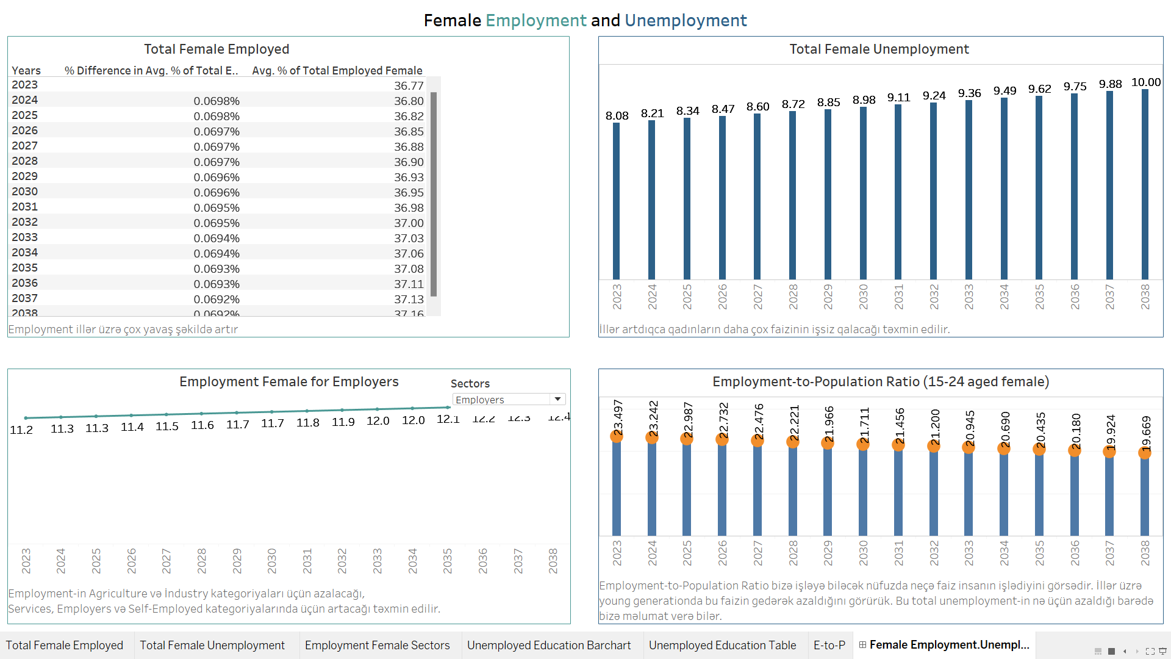

In the above dashboard, the observations and the trends from the graphical data available on women's employment in various sectors of the Azerbaijani labor market are presented.

In the following chapter, I will dive into short description of the trends and possible causes for why such a tendency has been followed.

##### Employment

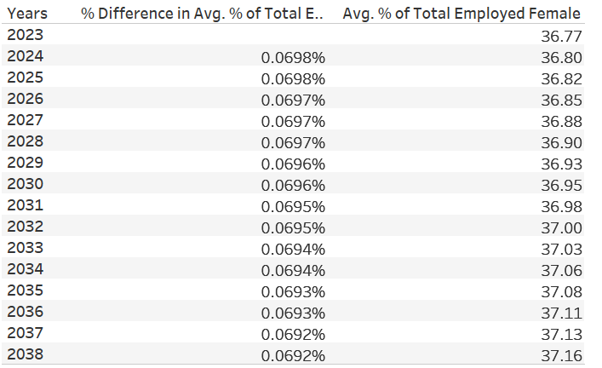

Figure 1: Table for expected female employment in upcoming 15 years

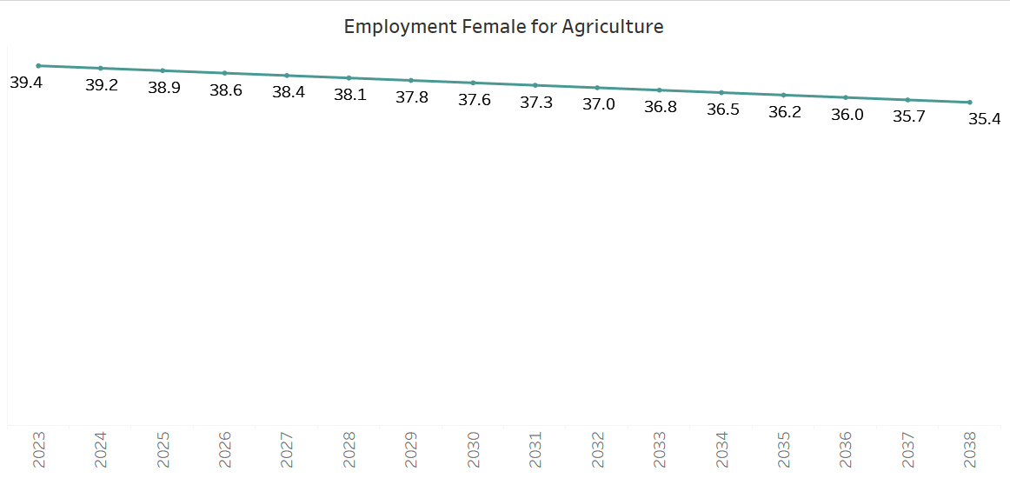

Figure 2: Expected female employment in Agriculture sector in upcoming 15 years

##### 1. Agriculture Sector

The % of female employment has fallen starting from 39.4% in the year 2023 and finalizing the decreasing trend with 35.4% in the year 2038.

1.1 Potential Causes:

* **Rural-to-urban migration**: Women could be migrating from rural agricultural jobs to cities in search of better opportunities.
* **Mechanization:** Greater mechanization and industrialization of agriculture may decrease labor demand.

The general trend that is taking place in the world is moving away from agriculture into services and manufacturing, and this could also be one of the reasons that the falling percentage of women into agriculture is accelerating.

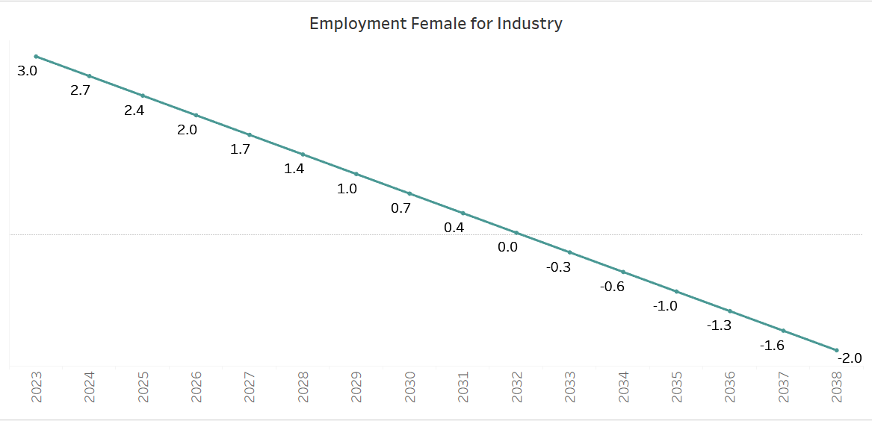

Figure 3: Expected female employment in Industry sector in upcoming 15 years

##### 2. Industry Sector

There is an evident fall in the percentage of female employment in the industries. Employment has shifted from 3.0% in 2023 to -2.0% in 2038.

2.1 Potential Causes:

* **Automation:** Similar to Agriculture, Industries are also getting automated, requiring fewer or no human resources and hence in particular devoid of female participation.
* **Industry** (construction, manufacturing, and heavy machinery) **sector being male-dominated**: Male employment growth in these areas may not translate into a proportionate increase in the female share that explains the slight decrease in the shares during this period.
* **Shift to Technology and Services**: Most countries of the world, Azerbaijan being no exception, are shifting towards service-based economies. This can be another reason for the relatively lower female entry into the industrious occupations.

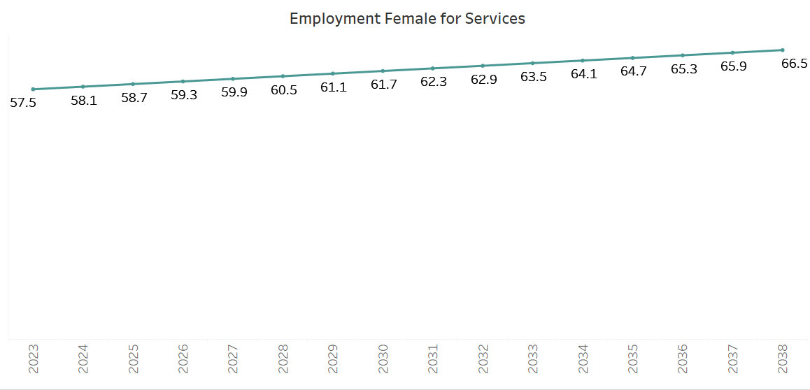

Figure 4: Expected female employment in Services sector in upcoming 15 years

###### 3. Services Sector

The female workforce is increasing at a slow and steady pace in services. The percentage recorded in 2023 was 57.5%, and the increased rate was 66.5% in 2038.

3.1 Potential Causes:

* **Flexibility and Opportunities:** On the whole, the nature of work in the service industry is much better regarding flexibility and could be more appealing to women, especially those who have to balance work and family obligations.
* **Growing Demand:** The service sector has grown rapidly, and with improved working conditions and increased demand from the IT industry, health, and education, more women have entered the labor market.

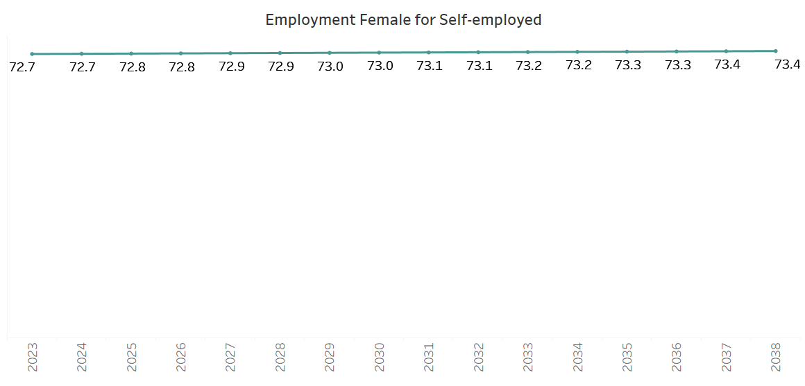

Figure 5: Expected employment for Self-Employed female in upcoming 15 years

###### 4. Self-Employment

Over the years, the percentage share of women in self-employment has hovered between approximately 72.7% and 73.4%.

4.1 Potential Causes:

* **Growth of Entrepreneurship:** More women could have initiated their venture or engaged in self-employment activities because of the flexibility it offers them.
* **Scarcity in Job Availability:** Where there is a shortage of formal employment within the region, one can end up being self-employed.
* **Cultural Factors:** It is the culture or social influence aspects that make women choose to be self-employed rather than seeking regular jobs within particular sectors.

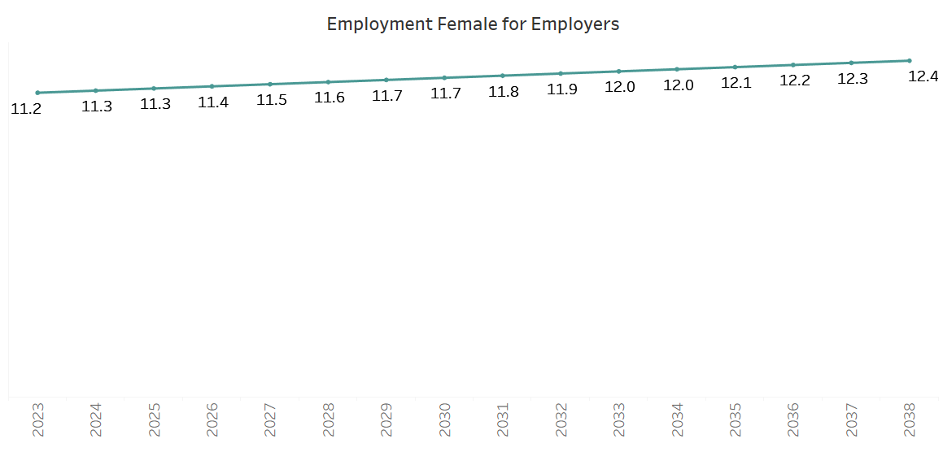

Figure 5: Expected Employer female growth in upcoming 15 years

###### 5. Employers

The female workers who are employers are on the rise from 11.2% in 2023 to 12.4% by 2038.

5.1 Potential Causes

* **Leadership and Ownership:** More and more women take up leadership positions, owning businesses and, therefore, becoming employers.
* **Government and Policy Supports:** Government policy supports female entrepreneurship and leadership, gradually but surely, to increase the proportion of women being employers.

###### Summary

From the given data, it would seem that female employments in agriculture and industry are inversely related to their employments in services. That is, with growth in the services sector, many of them are probably moving out of the traditional sectors of agriculture and industry into services since these offer more scope and opportunities for growth.

Service employers and services move together. As more females are employed in services, so does the number of employers who are females increase. It can be thought that the more women are involved in service industries, the more they also become owners and leaders of these very industries.

##### Unemployment

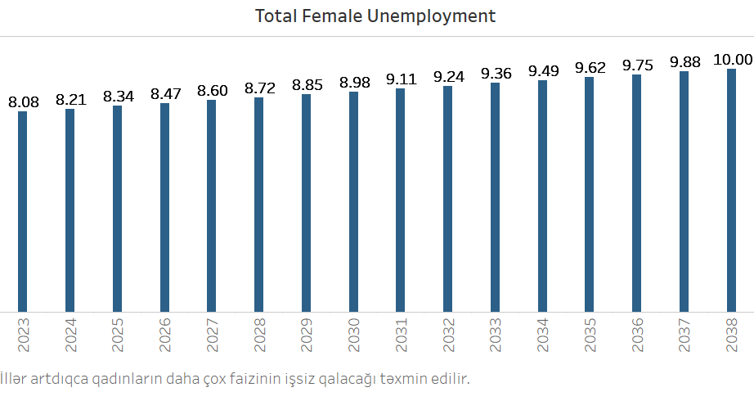

Figure 6: Graph for expected female unemployment in upcoming 15 years

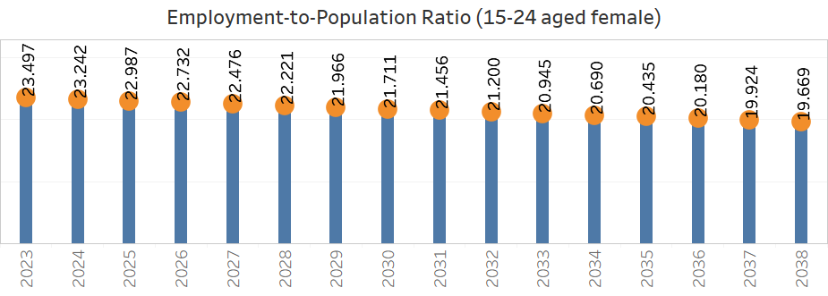

Figure 7: Employment-to-Population Ratio for 15-24 aged female

The two charts paint a concerning picture of the female labor market:

* Unemployment rates are projected to increase steadily, suggesting growing challenges for women in securing employment over the next decade.
* The employment-to-population ratio for younger women (aged 15-24) is expected to decrease, indicating fewer young women in the workforce.

Potential Causes:

* **Higher Education and Postponed Entry into the Workforce**: As young women increasingly pursue higher education, the time they spend in school tend to delay their entry into the labor market. This can explain the declining employment-to-population ratio for young women aged 15-24.
* **Rural-Urban Divide**: Women in rural areas tend to have fewer employment opportunities than those in urban centers like Baku, where service and professional sectors are more developed. This can widen the unemployment gap for women in certain regions of the country.
* **Wage Inequality**: Gender pay gaps can discourage women from participating fully in the labor force if they perceive the economic returns from working as insufficient relative to their household responsibilities or other activities.
* **Traditional Gender Roles**: In Azerbaijan, traditional family roles may limit women's participation in the workforce, especially after marriage or childbirth. Many women may leave the labor market to focus on family responsibilities, contributing to higher unemployment.
* **Job Market Mismatch**:As Azerbaijani economy is dependent more on capital-intensive sectors (such as oil, gas, and construction), jobs that are traditionally male-dominated, sectors with higher female participation, like education, healthcare, and services, may not grow at the same rate.

##### Conclusion

The trends reflected in the above charts point to growing challenges for female employment in Azerbaijan. While the service sector offers a glimmer of hope, significant barriers remain for women in agriculture and industry, where job losses are expected. Younger women are likely to face decreasing employment prospects, and overall female unemployment is projected to rise steadily over the coming years.

#### Male Employment and Unemployment

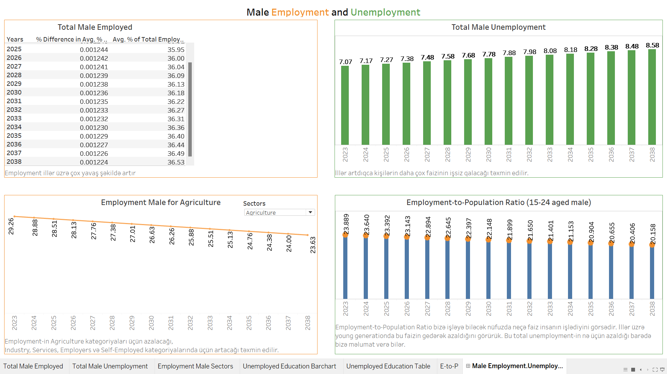

In the above dashboard, the observations and the trends from the graphical data available on men's employment in various sectors of the Azerbaijani labor market are presented.

In the following chapter, I will dive into short description of the trends and possible causes for why such a tendency has been followed.

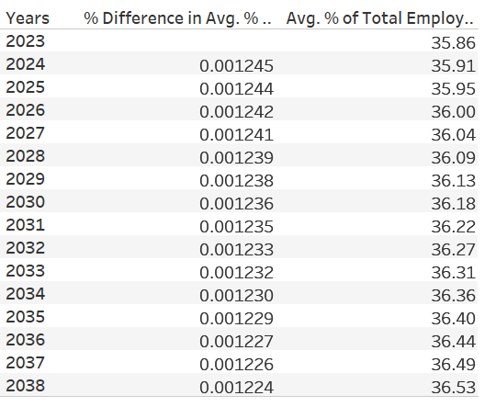

Figure 8: Table for expected male employment in upcoming 15 years

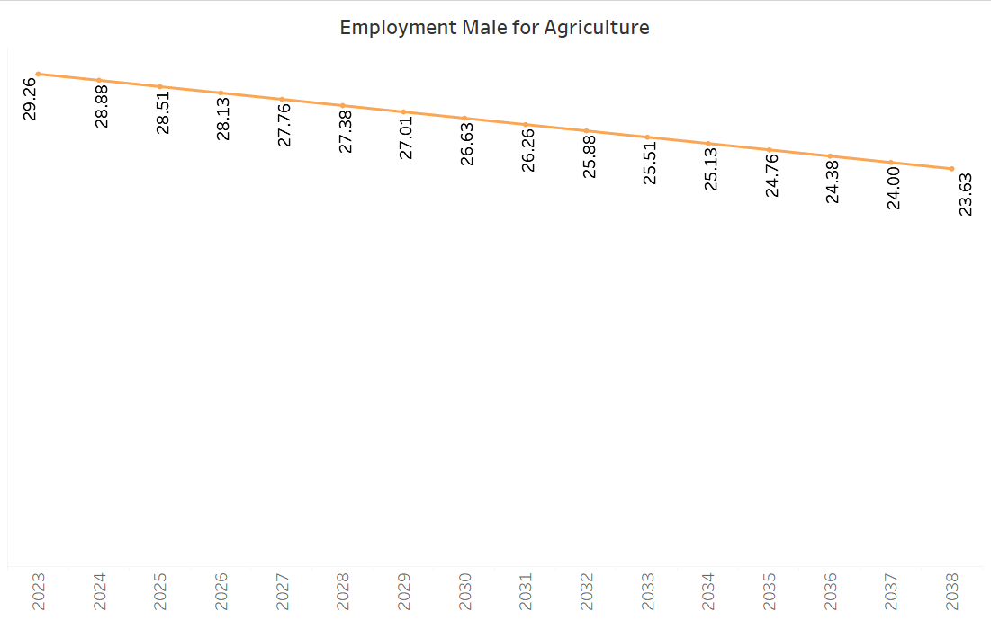

Figure 9: Expected male employment in Agriculture sector in upcoming 15 years

##### 1. Agriculture Sector

The share of males employed in agriculture shows a consistent decline from 29.26% in 2023 to 23.63% by 2038.

1.1 Potential Causes:

* **Mechanization and Technological Advances**: Agriculture has become increasingly mechanized, requiring fewer laborers to perform tasks that were once labor-intensive.
* **Rural-to-Urban Migration**: Many workers, especially males, are migrating from rural areas to cities in search of better-paying and more stable jobs.
* **Low Productivity and Income in Agriculture**: Agriculture is not as financially rewarding as other sectors, prompting men to leave it.

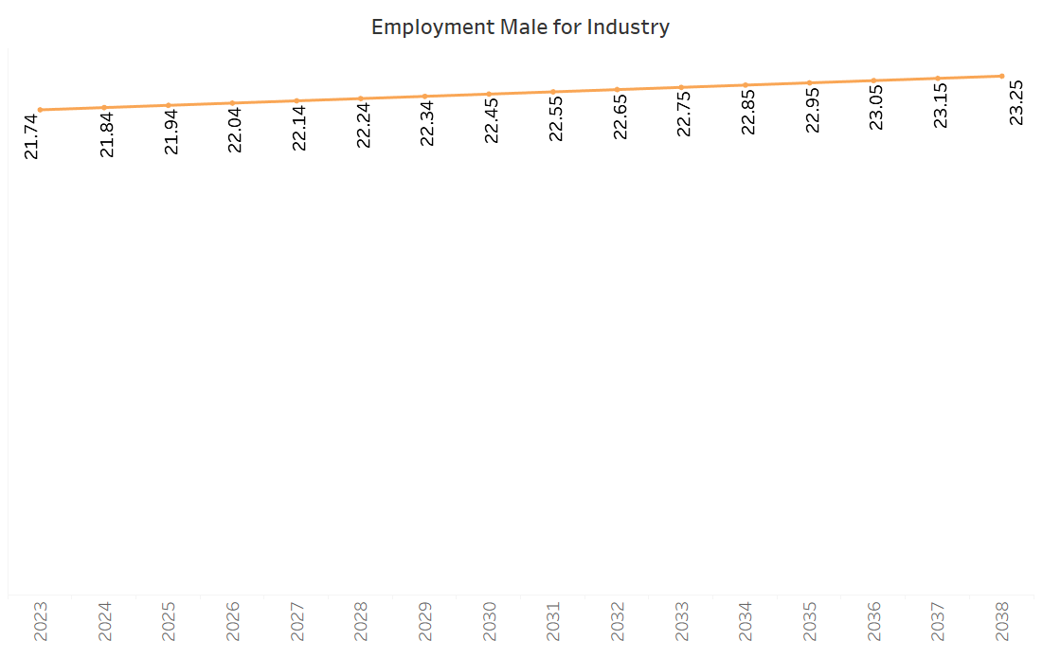

Figure 10: Expected male employment in Industry sector in upcoming 15 years

##### 2. Industry Sector

Male employment in industry shows a steady increase from 21.74% in 2023 to 23.25% by 2038.

2.1 Potential Causes:

* **Industrial Development and Diversification**: Azerbaijan’s economy is expanding beyond oil and gas extraction into manufacturing, construction, and infrastructure development. There are more jobs available in the industrial sector, where men are traditionally employed.

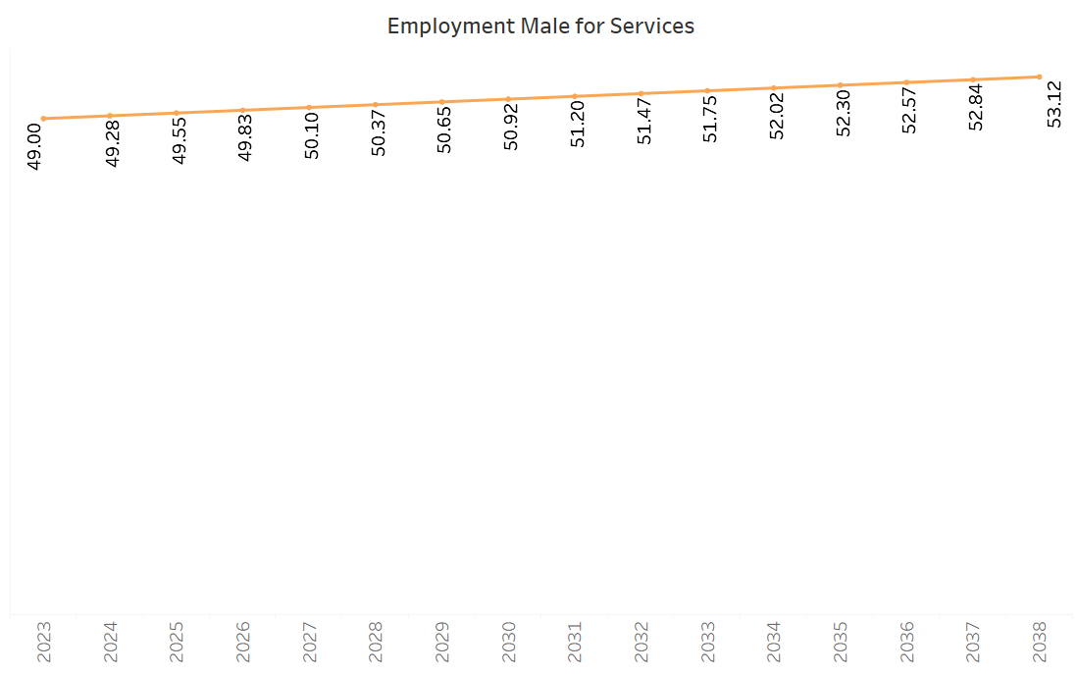

Figure 11: Expected male employment in Services sector in upcoming 15 years

###### 3. Services Sector

The services sector shows a steady growth in male employment, increasing from 49.00% in 2023 to 53.12% by 2038.

3.1 Potential Causes:

* **Urbanization and Expansion of the Services Economy**: As Azerbaijan urbanizes, the demand for services like retail, healthcare, education, tourism, and professional services is increasing.

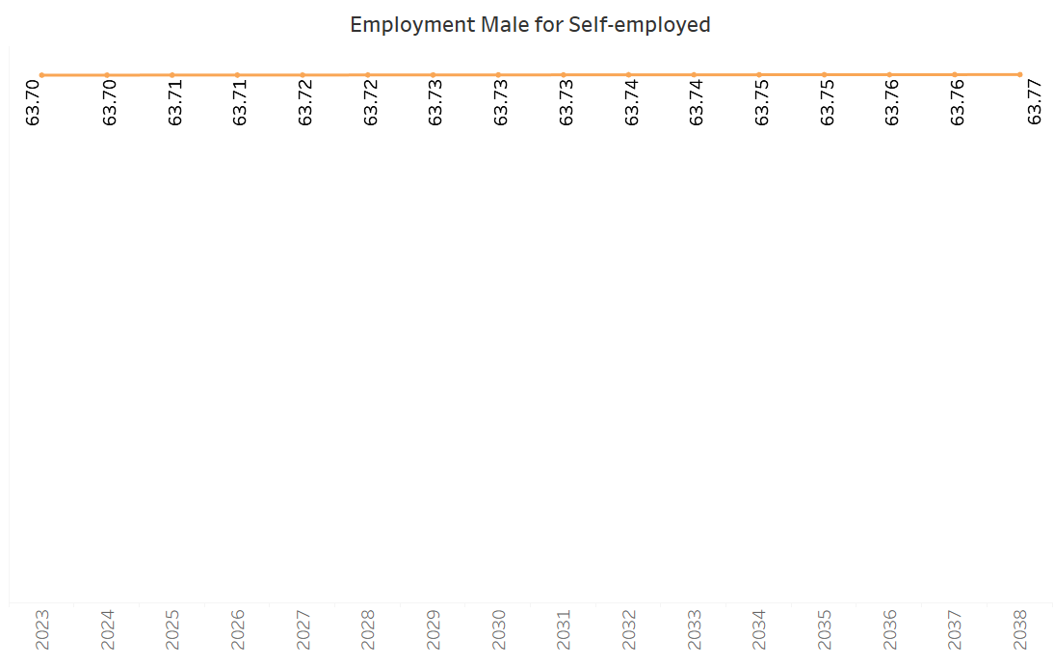

Figure 12: Expected employment for Self-Employed male in upcoming 15 years

###### 4. Self-Employment

Male self-employment remains very stable, moving only slightly from 63.70% in 2023 to 63.77% by 2038.

4.1 Potential Causes:

* **Tradition of Entrepreneurship**: Azerbaijan has a strong culture of entrepreneurship, especially in urban areas where family-owned businesses and small enterprises are common. Many men work as self-employed individuals, running small shops, transportation services, or informal businesses. This tradition of self-employment explains why the percentage of self-employed males remains stable over the years.

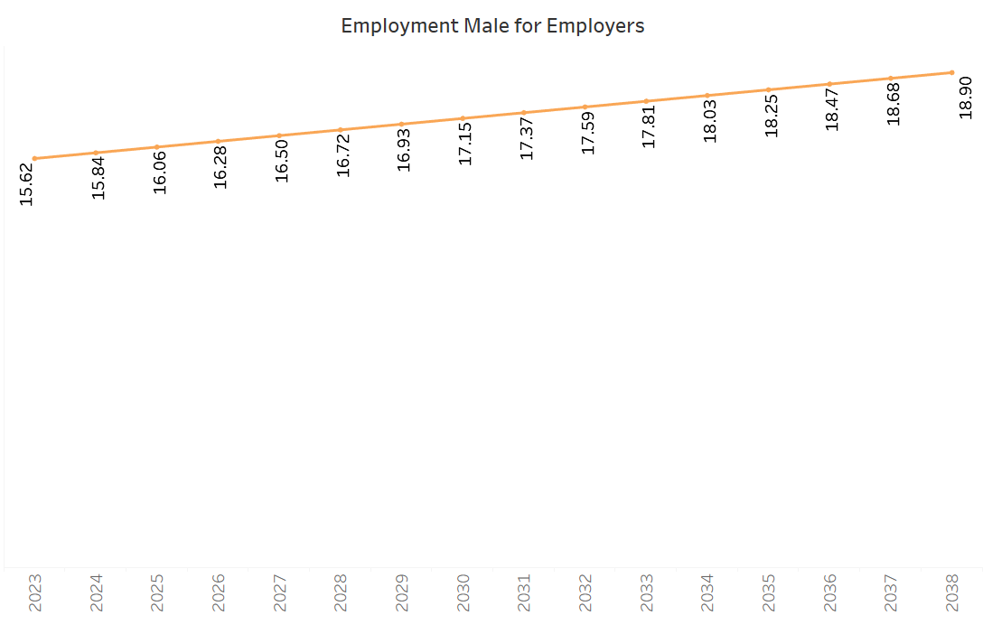

Figure 13: Expected Employer male growth in upcoming 15 years

###### 5. Employers

The percentage of males working as employers shows a gradual increase, from 15.62% in 2023 to 18.90% by 2038.

5.1 Potential Causes:

* **Emerging Entrepreneurial Opportunities**: The growing male participation as employers reflects increasing entrepreneurial opportunities, especially in sectors like construction, retail, and hospitality. Government policies that support small and medium-sized enterprises (SMEs) may encourage men to transition from employees to employers, running businesses that hire others.

###### Summary

From the given data, it would seem that the male employment trends in Azerbaijan are shaped by a combination of structural economic changes, governmental policies, and social factors.

The decline in agriculture and the growth of industry and services reflect broader shifts in Azerbaijan's economy toward urbanization, industrialization, and diversification.

Stability in self-employment and growing male entrepreneurship show the resilience of the informal economy and the emergence of new opportunities for business ownership.

##### Unemployment

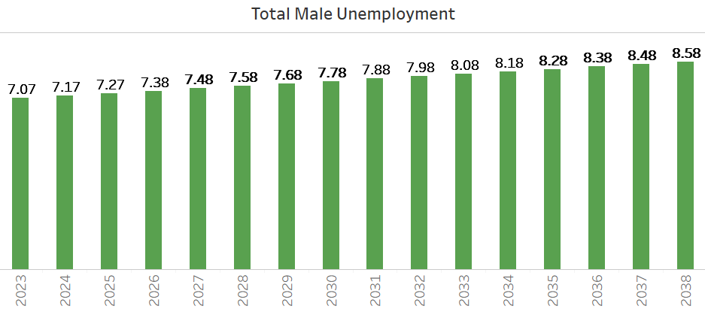

Figure 14: Graph for expected male unemployment in upcoming 15 years

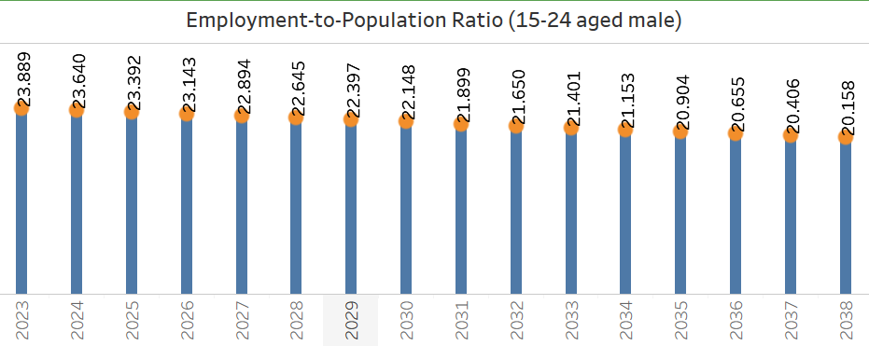

Figure 15: Employment-to-Population Ratio for 15-24 aged male

The two charts paint a concerning picture of the male labor market:

* Unemployment rates are projected to increase steadily, suggesting growing challenges for men in securing employment over the next decade.
* The employment-to-population ratio for younger men (aged 15-24) is expected to decrease, indicating fewer young men in the workforce.

Potential Causes

**Lack of Skills for New Jobs**: As the economy modernizes, the demand for high-skilled labor is increasing. Men with skills specific to declining industries (e.g., agriculture, low-tech manufacturing) can find it difficult to transition into growing sectors like services and technology due to inadequate education or training.

**Prolonged Education or Discouragement**: More young men tend to stay in school longer, delaying their entry into the workforce. Additionally, some young men can become discouraged after multiple unsuccessful job searches, leading to withdrawal from the labor market and an increase in unemployment.

**Fluctuations in the Oil and Gas Industry**: Azerbaijan's economy is heavily reliant on the oil and gas industry. Any downturns or fluctuations in global oil prices can lead to job losses in this sector, disproportionately affecting male workers. Unemployment can rise during periods of low oil prices as investments in the industry slow down.

**Automation of Traditional Jobs**: The increasing use of technology and automation in industries like manufacturing, agriculture, and logistics may displace male workers who perform manual or repetitive tasks. This can lead to job losses, particularly among men who may not have the technical skills needed for more advanced roles.

##### Conclusion

The gradual increase in male unemployment in Azerbaijan can be attributed to multiple factors, including structural shifts in the economy, skill mismatches, automation, youth unemployment, and economic volatility in key sectors like oil and gas. Addressing these challenges will require targeted interventions, such as retraining programs, improved vocational education, government support for job creation in emerging sectors, and policies that better integrate young men into the labor market.